To support students and caregivers in continuing with learning opportunities during school closure, we’ve created DMPS@home, a three-pronged approach that includes links to high quality web resources, print materials distributed at school sites, and optional activities and lessons in Canvas. This guide will help students and caregivers access those materials. For a brief video overview, go to this link: https://tinyurl.com/canvasforDMPSfamilies

What is Canvas and how do students access it?

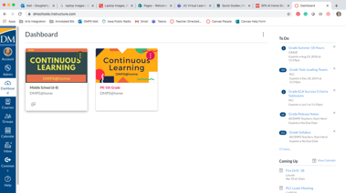
Canvas is our Learning Management System, which connects the digital tools teachers, students, and parents use. Students will use the following information to log on:
- The username is your student ID.
- The default password is
- Links directly to Canvas are found on the DMPS Website. The address is https://dmschools.instructure.com/login/canvas

Once we log into Canvas, what should we see or do?

Your first stop, once logged into Canvas, is the dashboard. Here you will find a menu of courses the student is currently enrolled in. For our continuous learning through school closure, students will see these one of courses on their dashboard or in their course list depending on their grade level:
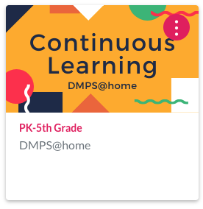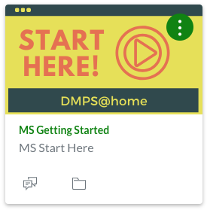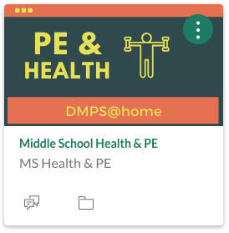
Clicking on the course tile will take you to a menu of grade levels. Students and caregivers have full access to all content in all grade levels through this course. Clicking on the grade level for your course will take you to a page for each week remaining in the school year. New content will be released weekly. Click on the week for which you are seeking materials. Then, clicking on the grade level for your student will take you to a menu of subjects. Click on any subject to find activities and materials for that week of learning. There is also a library of resources for caregivers to help make decisions about how much time you might expect students to spend learning during school closure.

What if we need help using Canvas?
There are lots of ways to get help!

- If you need simple support for finding learning materials or with the activities themselves, reach out to your teacher.
- Send a message to this email address for your school requesting support:

- Looking to learn even more about Canvas itself? Visit canvaslms.com and explore the guides and information you’ll find there.

