Using Samsung Device as a Hotspot
Power on the phone
-The power button is on the right side, under the volume
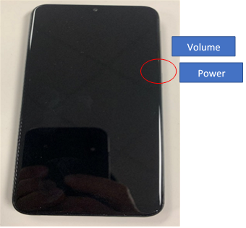

When the phone turns on fully, select the under “Let’s Go”

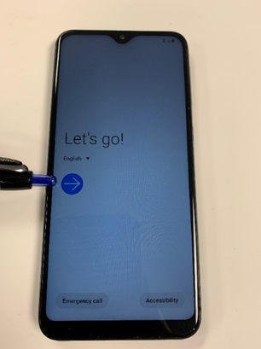

Select the option “I have read and agree to all of the above.”
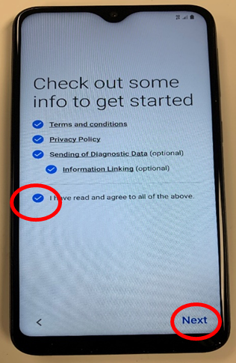
Then select “Next”

Your device will check for its activation. It is already activated. When the phone finishes this, click “Next.”
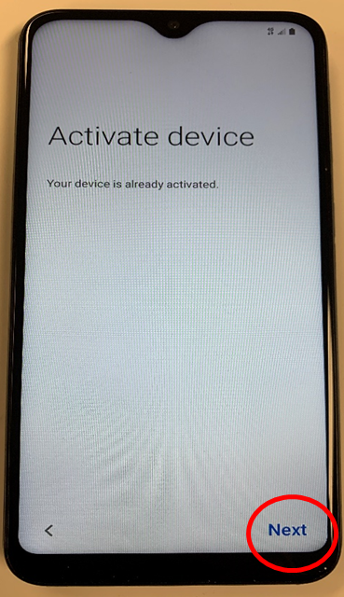

You’ll be prompted to setup your old data. Select “Skip this for now.”
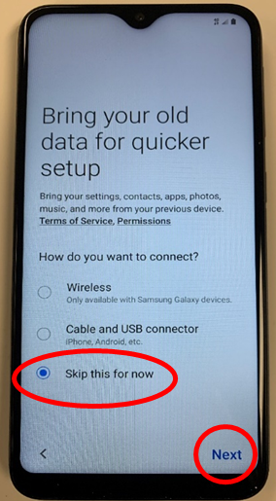
Then click “Next”

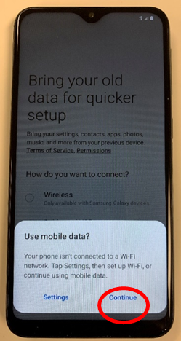
The phone will ask you to use mobile data. Click “Continue”

The phone will do a quick update and then ask you to begin setting up your device.
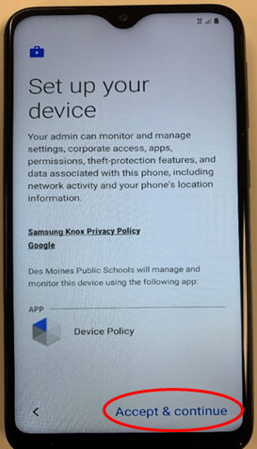
You’ll be prompted to review the Samsung Knox Privacy Policy. You can click “Accept and continue”

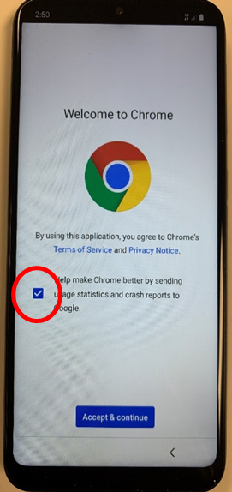
Your device will go through a configuration and another update. Wait for the screen to say “Welcome to Chrome.”

Uncheck the box next to “Help make Chrome better…”
Then tap, “Accept and continue” below it.
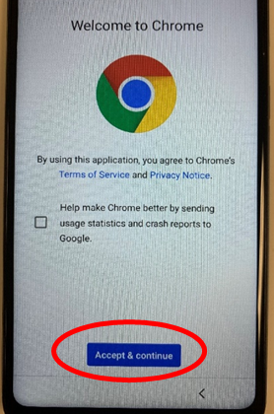

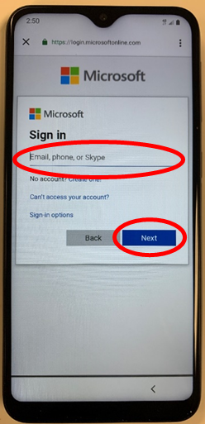

You’ll be prompted to sign into Microsoft. You’ll need to use your student account (000000@student.dmschools.org)
Tap “Next” (or select “Go” on the keyboard)
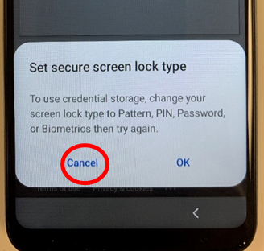
When asked about “Set secure screen lock type,” please select “Cancel”

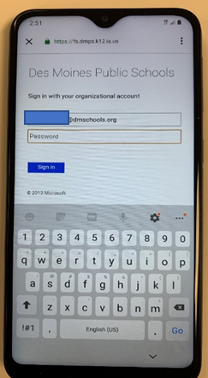
After you key in your student ID, you’ll be prompted to key in your password. Type in your password and select “Sign In.”

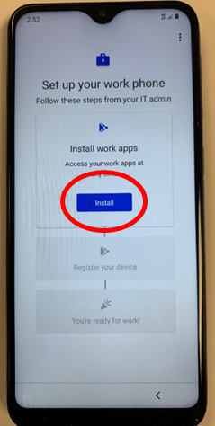
Your phone will go through another sequence of updates.
Afterwards, you’ll be prompted to install a few apps.

Select “Install”

On the next screen, tap “Next”
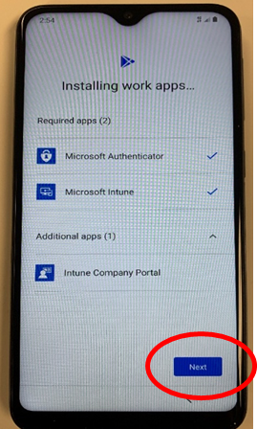
The apps will install.

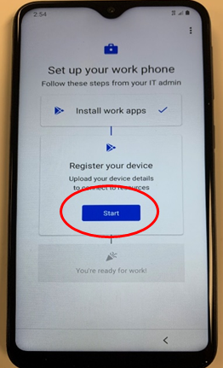

When asked to “Register your device, tap “Start.”

You’ll come to a blue screen labeled “InTune.
Select “Sign In”
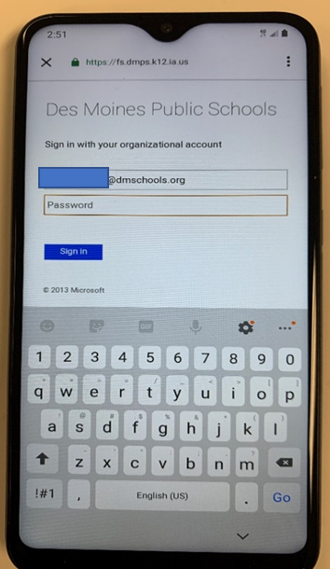
And then, sign into your district account again.
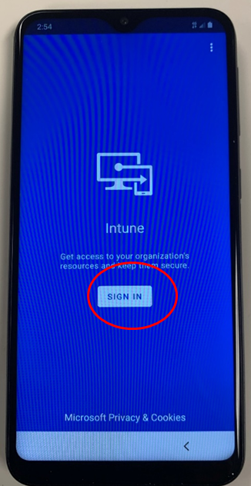

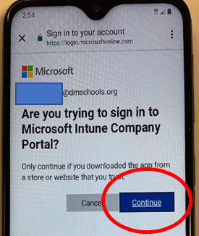

If asked “Are you trying to sign in to Microsoft Intune Company Portal?”, select “Continue.

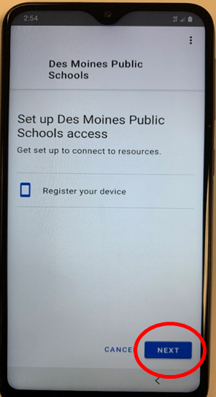
You’ll need to register your phone next. Select “Next.”

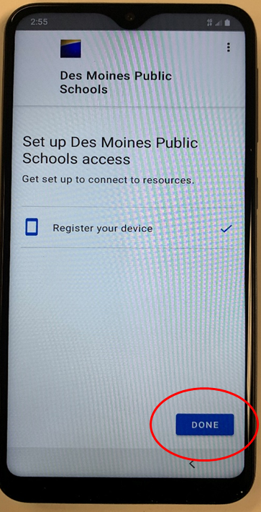

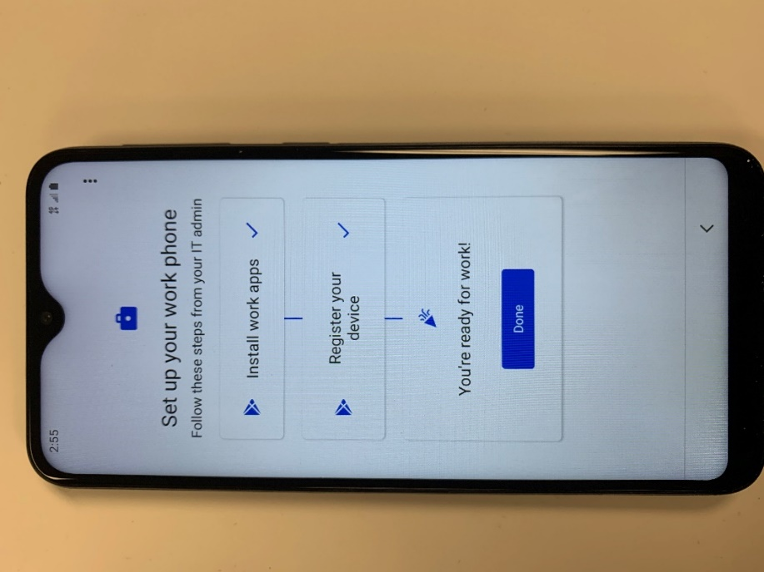
When it’s all done, now click “Done.”
Then click “Done” again.

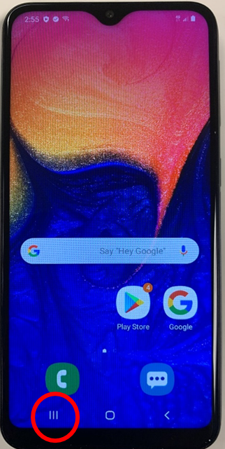
Click on the three bar ||| in the lower left corner of the screen.

Tap the settings icon.

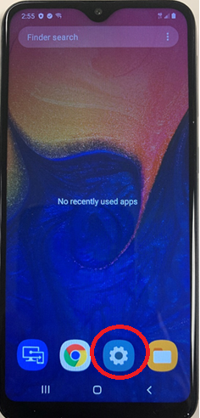
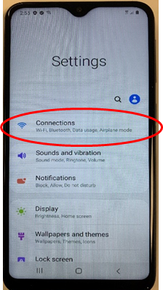
In ‘Settings,’ select “Connections”

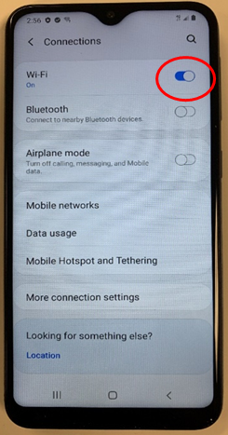

Turn off the wireless by tapping on the toggle switch next to the Wireless option.

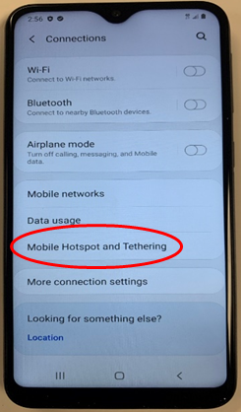
Once the WiFi is off, select “Mobile Hotspot and Tethering.”

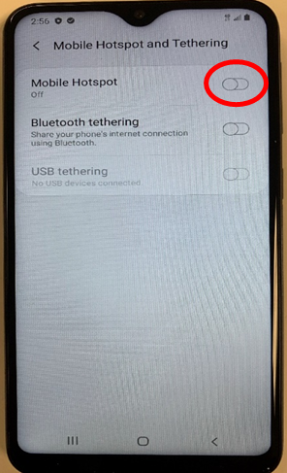

In the “Mobile Hotspot and Tethering,” toggle the “Mobile Hotspot from “Off” to “On.”

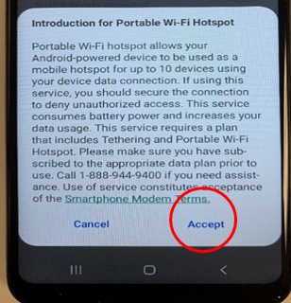
You’ll need to confirm you want to use data. Select “Accept.”

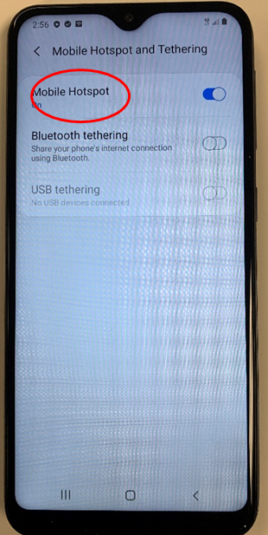
Once the mobile hotspot is turned on, tap on the text “Mobile Hotspot.”

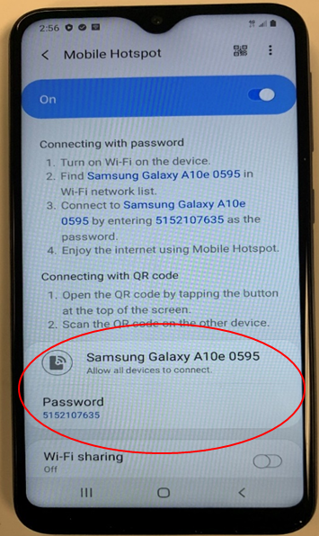
You’ll find the password you’ll need to type into your laptop to connect it to the WiFi.

Connecting your District Computer to your Samsung Hotspot
Be sure your Samsung Hotspot is powered on and the hotspot is enabled (previous steps above).
- Power on the computer, then press CTRL-ALT-DEL to get to logon screen. Once at screen click the WiFi icon (circled below)
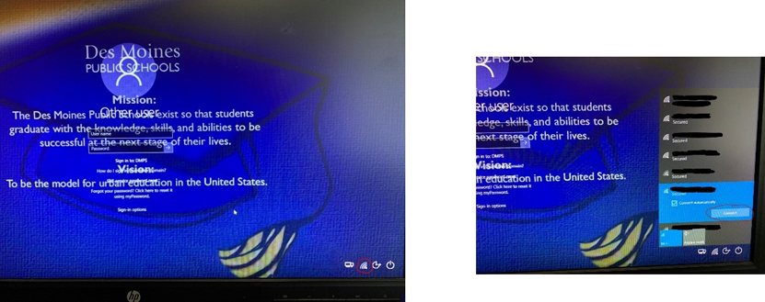
- Choose the name of your network (this is what you see above), then click “Connect” and enter your WiFi password or key. If entered properly, it should connect to your WiFi.

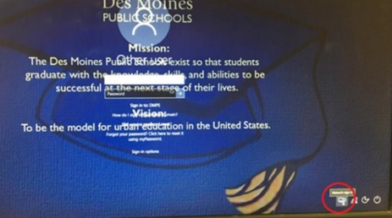
- To log onto the computer for the first time, click the icon that looks like two computer screens (circled below)

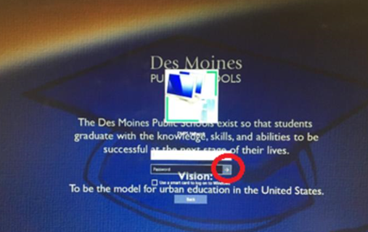
- Enter your email address (“studentID”@student.dmschools.org) and your password then click the arrow nest to your password (circled below). This should allow you to validate your account onto the Des Moines Public Schools network for future logons.

Connecting Personal Devices
If you are using your personal device to connect to your Samsung hotspot, you will need to follow your normal procedure for connecting to Wi-Fi, connecting to the Samsung hotspot name mentioned in the setup above.

